# EZLynx

## Details Tab

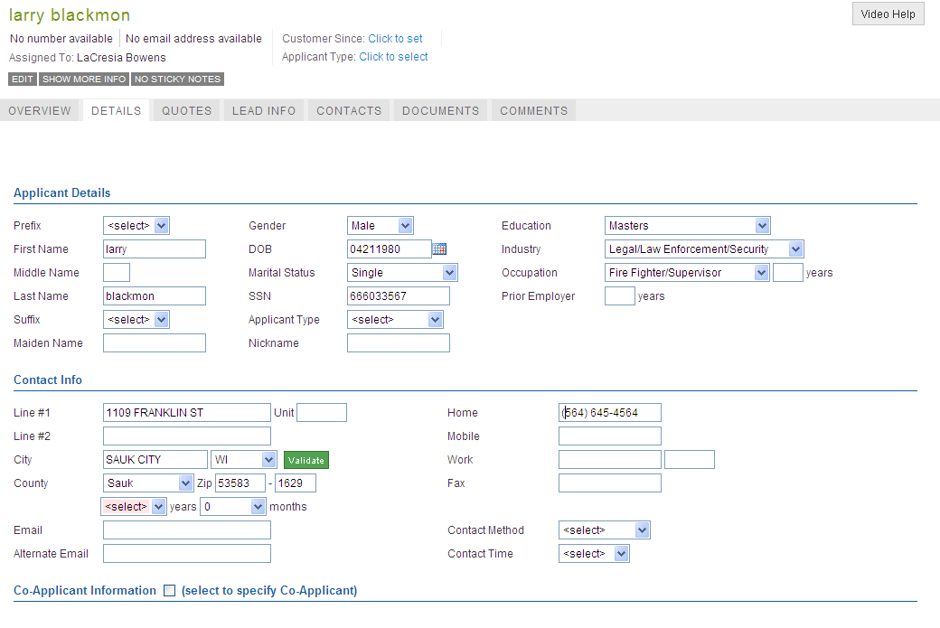

## Auto

### Policy Info

Red arrow indicates required fields

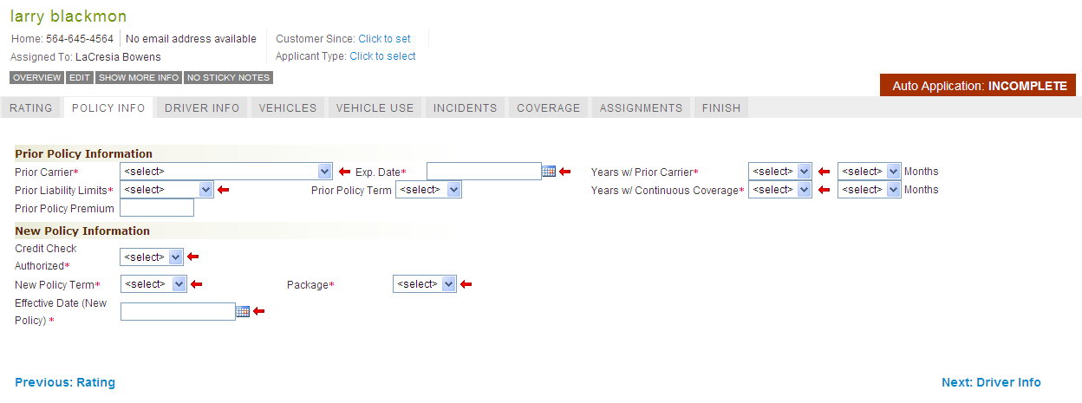

### Driver Info

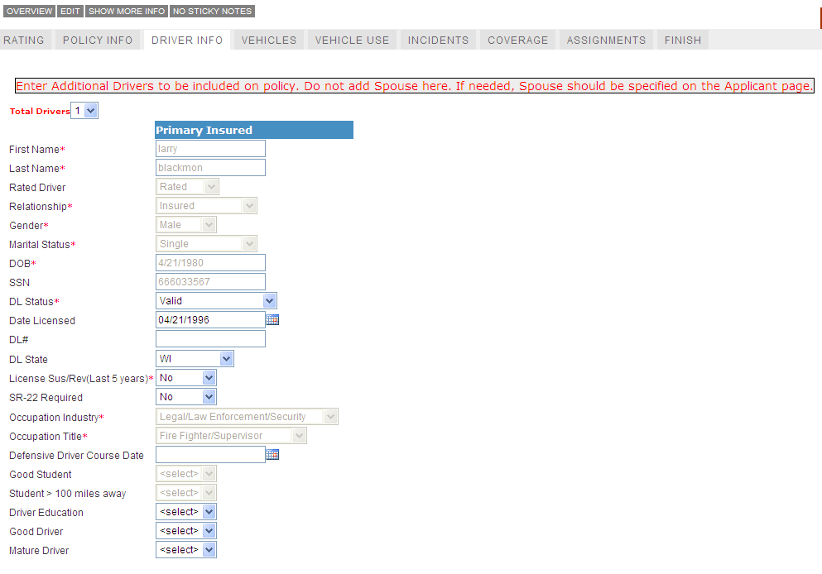

### Vehicles

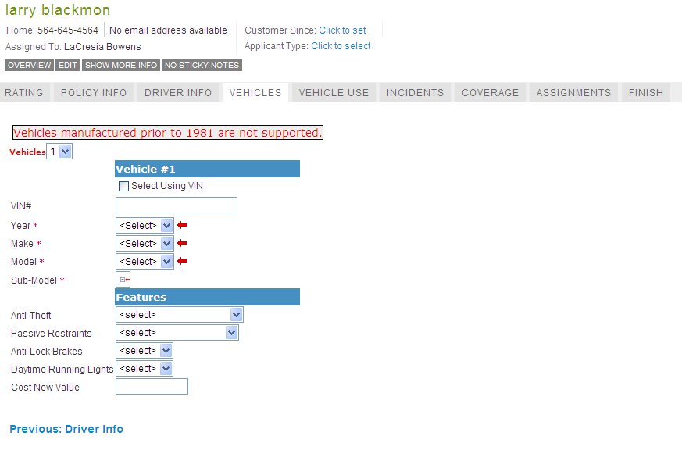

### Vehicle Use

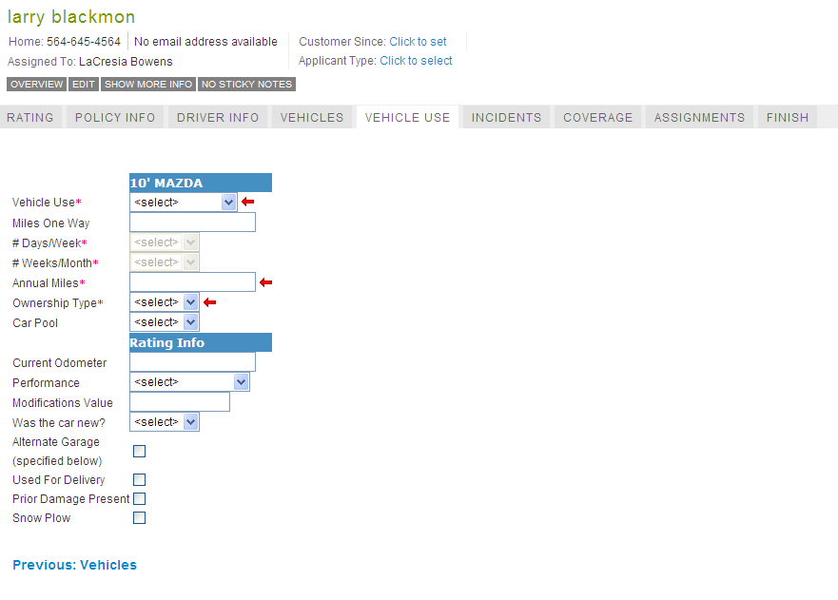

### Incidents

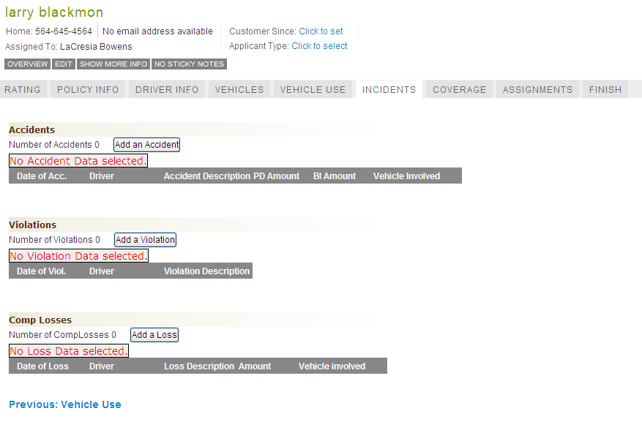

### Auto Coverage

Depending on state there may be state specific coverage options available. Example is WI.

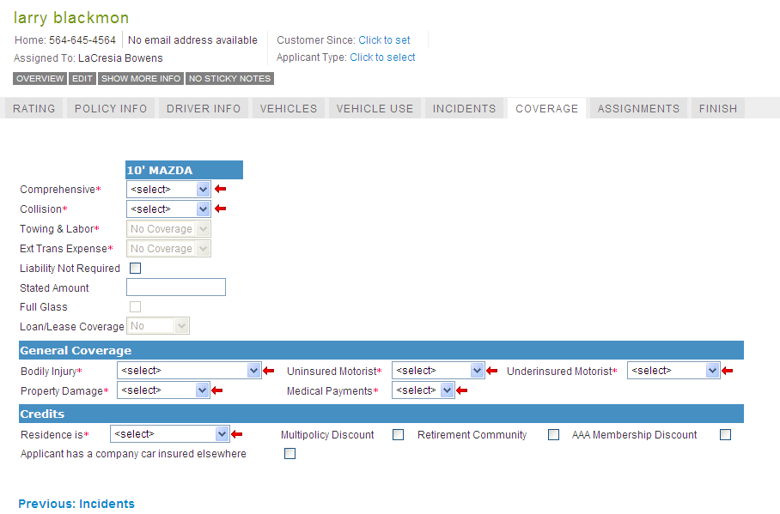

### Assignments

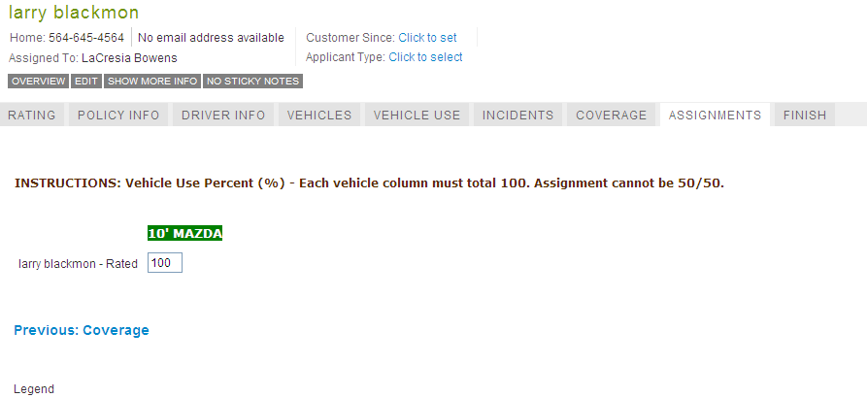

## Home

### Rating Tab



### Policy Info

Depending on state there may be state specific coverage options available. Example is WI.

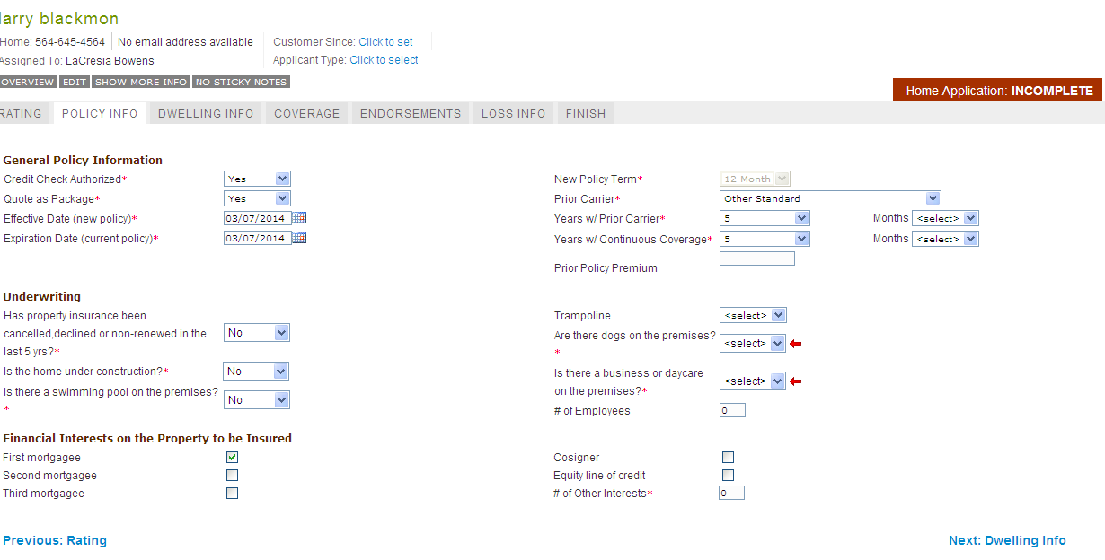

### Dwelling Info

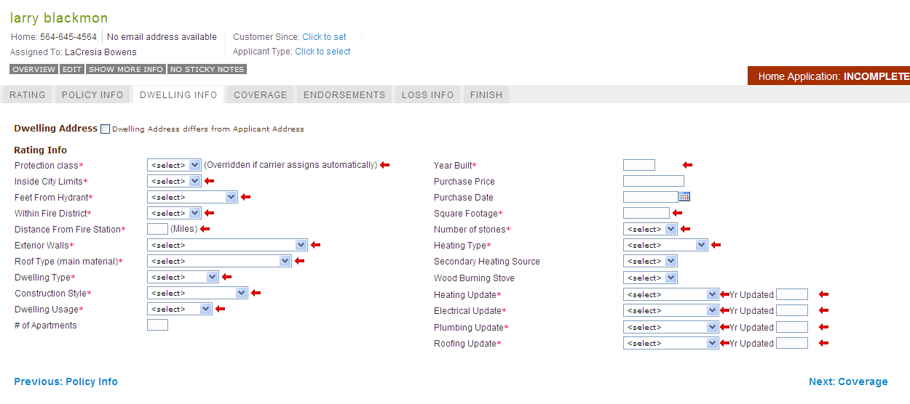

### Home Coverage

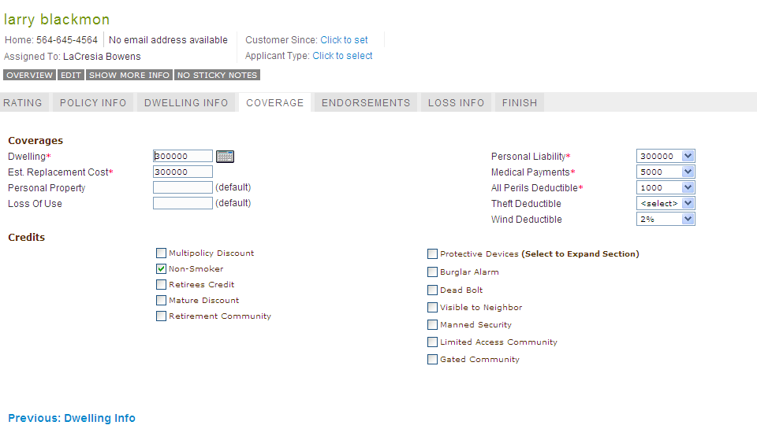

### Endorsements

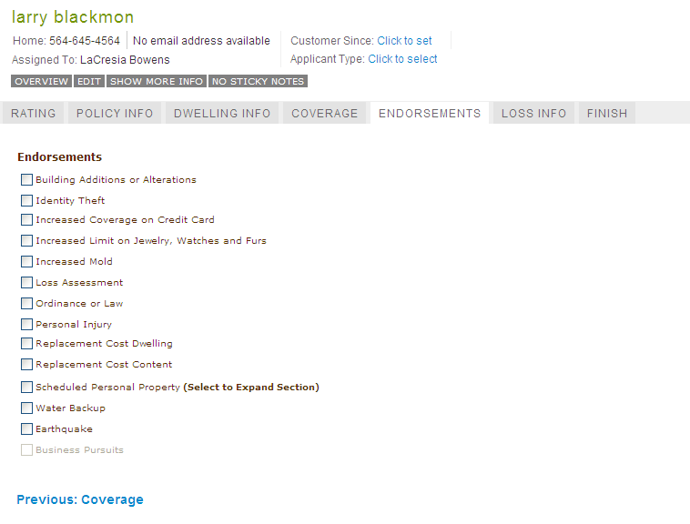

### Loss Info

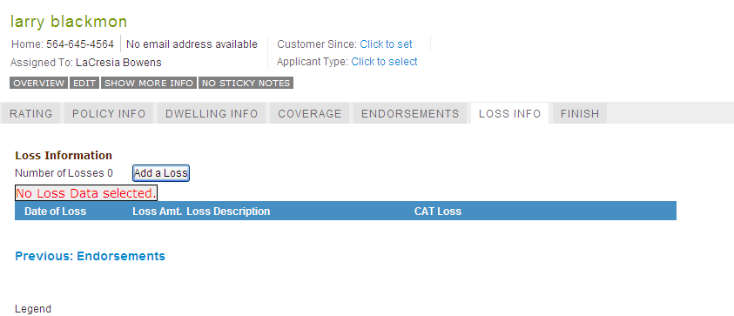

### Agents have a Carriers tab, which is not available to me. The below screenshot is from an agent. Notice how Kemper has more company unique questions than other carriers. We have a hyperlink that will expand the tile for capture more Property Information questions associated with our HOMVAL endorsement.

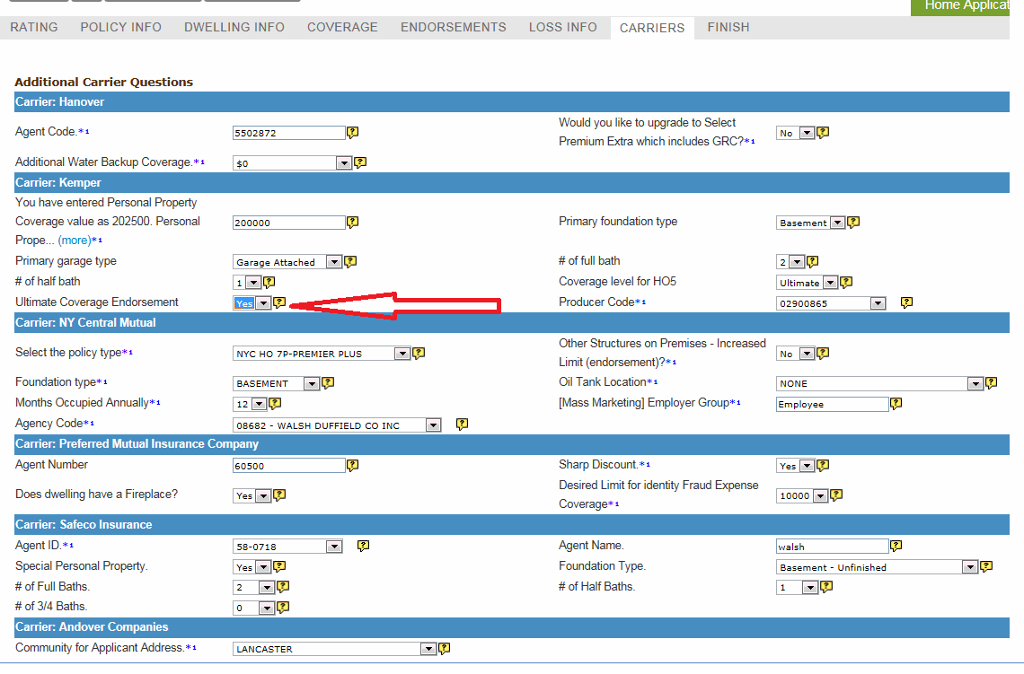

### Quote Details

